

# Introduction

The Survey Gizmo plugin allows you link SurveyGizmo to Rock, pulling survey answers into person records.

This plugin assumes you already have a Survey Gizmo account with several surveys created.

# Overview

Bundled into the Survey Gizmo Plugin are several different components. Each of these components has a specific purpose to enable the link between surveys and person records. Let’s look at these components.

# SETUP

## Configuring the Rock Job

**The first thing you will need to do is configure the Rock Job by setting the API Token and API Token Secret. The API token can be created on the Survey Gizmo website.**

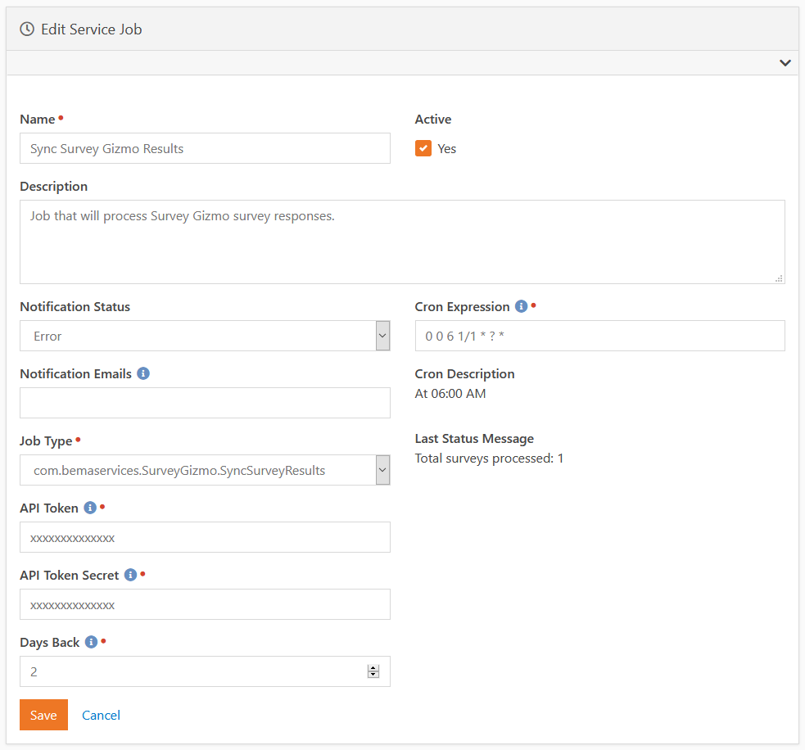

## Setting Up a Survey for Syncing

The next step will be to add a survey to be synced. This can be configured from the Survey Gizmo Surveys defined type.

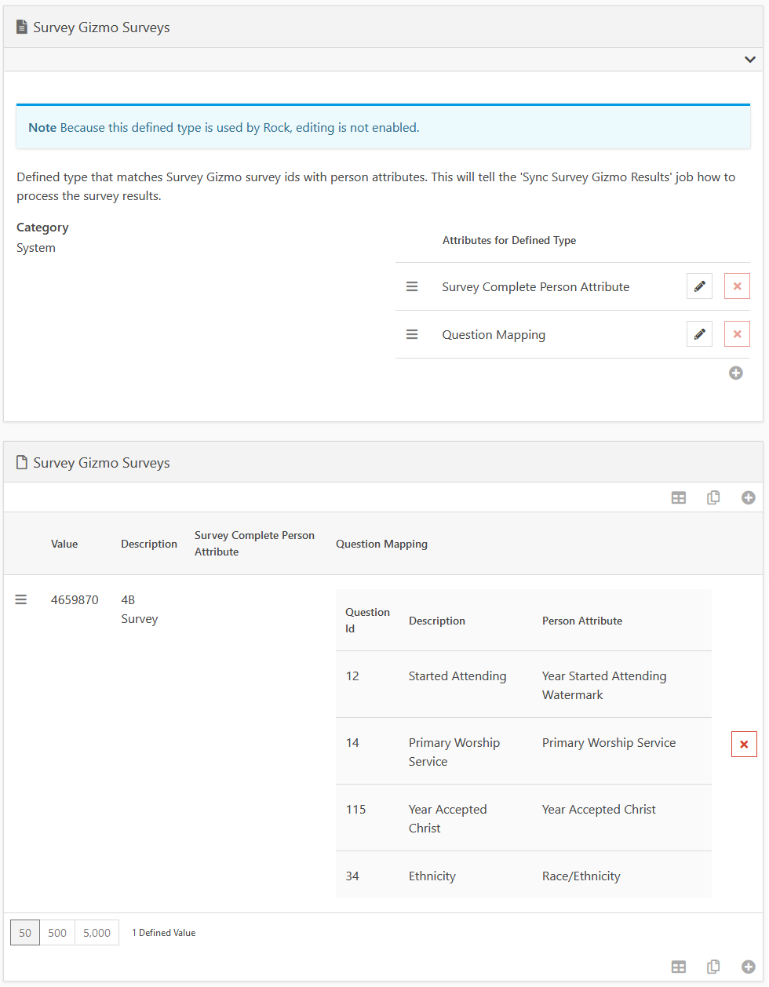

To add a survey, add a new defined value and configure the options below. It is a best practice to only create one defined value per survey.

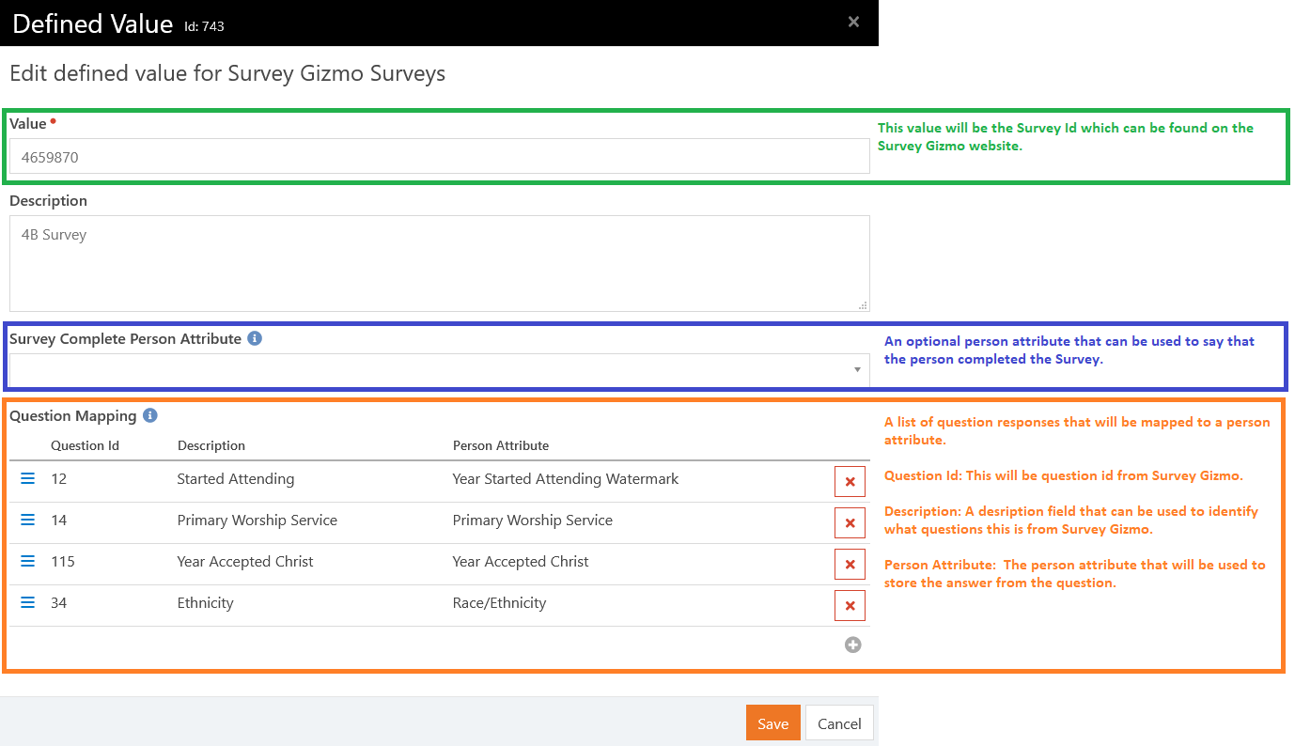

# Usage

Now that the survey is configured in Rock, the next step will be to setup the Survey Gizmo link in Rock. The survey link will need to contain a special URL parameter called ”*rockpersonaliasguid*”.This parameter ensures that the plugin will know who filled out the survey.

Here is an example of how you can setup the survey link in Rock using Lava:

**https://<SURVEY_GIZMO_LINK>?rockpersonaliasguid={{ CurrentPerson.PrimaryAlias.Guid }}**

Once your members have completed the survey, the Rock job will see the completed survey and will process the results. You can see how many surveys were processed by looking at the Last Status Message of the job:

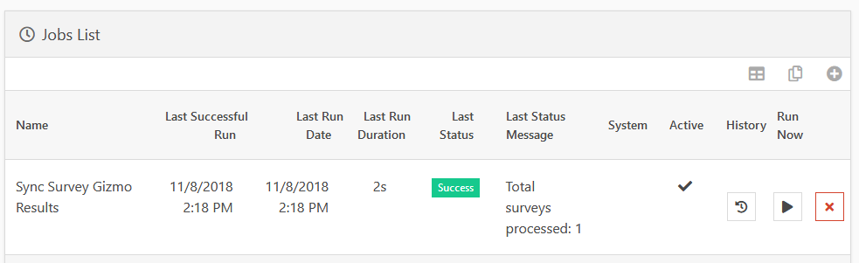

# F.A.Q.

Q: Why isn’t the Rock job processing any surveys?

A: For a survey to be processed by the plugin, the survey needs to have the following:

* The survey must be in a “Completed” state. Partial surveys are ignored since they could still be getting completed by the member.
* The survey must also include an URL parameter called “rockpersonaliasguid” that belongs to a person in Rock.

Q: I have a person attribute configured that is not saving the answer. What could be the problem?

A: It could be that you are using a person attribute that uses a Field Type other than “Text”. The Survey Gizmo works best with person attributes with a Field Type of “Text’.

